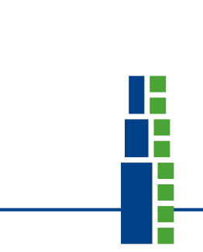

July 24, 2017
Dear Delegate of FIMM National member society!

It is my pleasure to send you the Invitation and programme for the
FIMM/NVAMG 2017 International Spine Conference - Diagnostics, interventions and epidemiology - the latest insights

May we also request that you send this invitation and information to your National colleagues so that all interested professionals can register and join us in the Netherlands.

This two-day conference takes place this year in Utrecht in the Netherlands with the Netherlands Association for Musculoskeletal Medicine (NVAMG) as co-host.
We hope to welcome many international colleagues and their partners. Much attention has been put into the scientific programmes on Saturday and Sunday in addition we offer interesting and enjoyable social programmes outside of the conference to relax or socialize with other international colleagues and discover Utrecht and all its beauty.

Please see our special conference webpage where all actual information can be found.

Hotel – Discount is available up to August 2nd!
If you are planning on staying in Utrecht during the conference please note that NVAMG/FIMM guests have an EXTRA DISCOUNT on the hotel if they book before the 2nd of August.
Link Hotel: http://www.nh-hotels.com/event/fimm-nvamg-conference
All questions about hotel reservations can be directed to NH Utrecht. Please mention your own personal reservation number or the group reservation number: MB0000591850

Information and Registration
Please go to https://www.nvamg.nl/fimmnvamg-2017-international-spine-conference-diagnostics-interventions-and-epidemiology-latest for all information and registration.

If you have any questions about the conference please feel free to call or e-mail our office +31 30 225 05 52 or info@nvamg.nl

We look forward to welcoming you and your colleagues 16 and 17 September in Utrecht, the Netherlands!

Met vriendelijke groet,

Kelley Post iov NVAMG

Nederlandse Vereniging van Artsen voor Musculoskeletale Geneeskunde (NVAMG)

